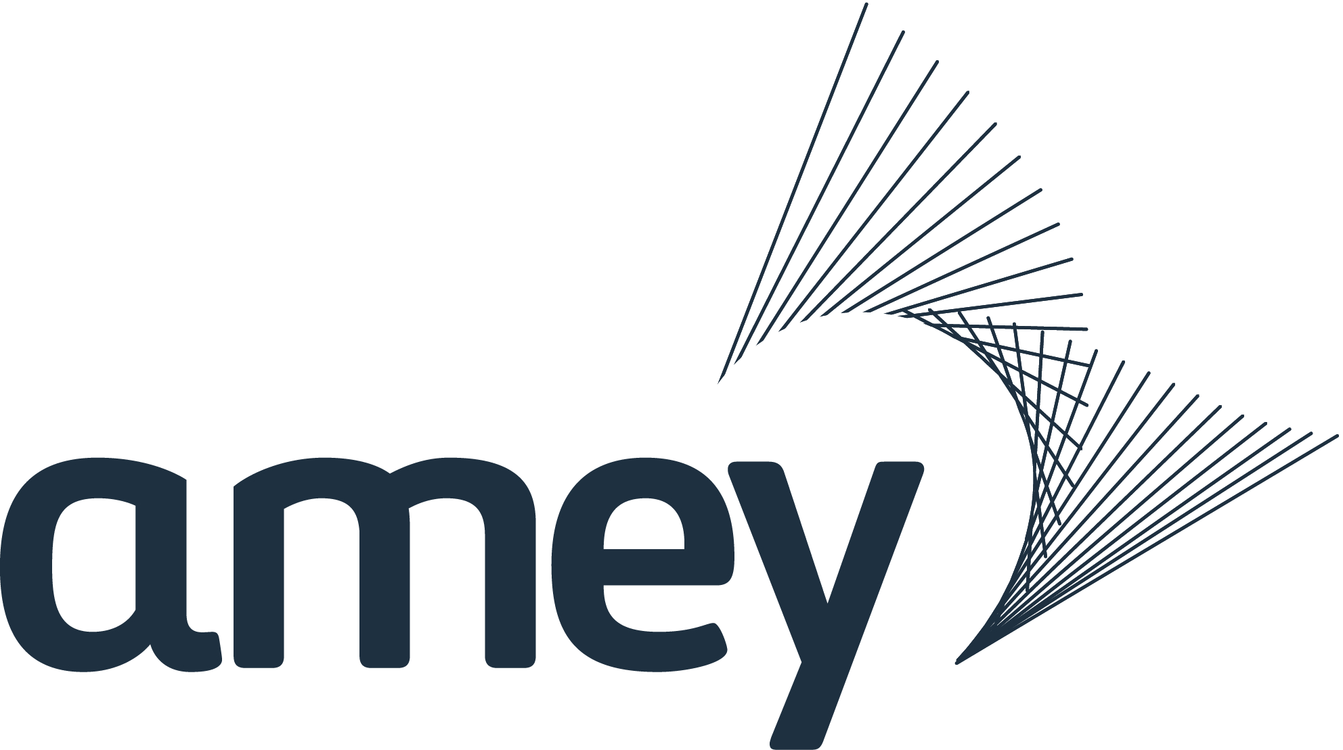

NEWS RELEASE

3 May 2022

Interested in the environment? Join us!

Are you interested in the environment and raising awareness of waste-related issues in your local community? Then we could have a role for you!

Allerton Waste Recovery Park (AWRP) treats all household waste from York and North Yorkshire and we are looking for new members to join our Stakeholder Panel.

The panel brings together a range of community, environment and industry representatives to explore raising local awareness of waste-related issues, and in particular promoting the 4 Rs of waste - Reduce, Reuse, Recycle, Recover.

“With waste and recycling very much in the news, our Stakeholder Panel brings fresh insight from their local communities, as we work with them to support their initiatives. Since opening in 2018, our dedicated education centre has welcomed over 4,000 residents, community groups and schools and we rely on the Panel to provide valuable feedback and help in shaping the visitor experience.” Colin Fletcher, Account Director, Allerton Waste Recovery Park.

If you are part of a community or environment-related group based in York and North Yorkshire and would like to find out more about joining the Stakeholder Panel, contact Emilie Knight, Community and Communications Manager emilie.knight@amey.co.uk.

Allerton Waste Recovery Park, is operated by Amey on behalf of North Yorkshire County Council and the City of York Council, and treats up to 320,000 tonnes of waste each year.

As well as using waste to generate enough electricity to power at least 40,000 homes, the facility also features technology that sorts the incoming household waste to extract materials suitable for recycling. Food waste is also separated and sent to an anaerobic digester where it creates renewable energy.

The visitor centre is open for local schools, community groups and residents. Visits include a site tour to view the state-of-the-art waste treatment technology and visits for schools and young people include recycling and waste related activities. Visits are free, for further information and to make a booking contact awrp.visitor@amey.co.uk.

Ends

Notes to editors:

Key facts about Amey

Amey, with a turnover of £2.2bn, employs 14,000 people internationally with a focus on the UK, but with businesses in Australia and America.
Our aim is to make the world a better place to live, work and travel. Designing, building, maintaining and investing in the UK’s services and infrastructure in partnership with our clients.
This means keeping core services running smoothly across the country: utilities, transport, engineering, justice, defence, environmental and waste services, and facilities management. These are underpinned by our leading consulting and asset management capabilities, which allow us to offer standalone or integrated service solutions to a range of clients.
Amey is owned by Ferrovial. They are one of the world’s leading infrastructure management and investment companies. Ferrovial has more than 96,000 employees and a presence in over 15 countries. It is a member of Spain’s blue-chip IBEX 35 index and is also included in prestigious sustainability indices such as the Dow Jones Sustainability Index and FTSE4Good. Ferrovial’s activities focus on four business sectors: construction, airports, toll roads and services. Amey is part of the Services division.
Follow us on Twitter @Ameyplc or Facebook @AmeyPlc
Media contact: Hayley.willis@amey.co.uk
Visit amey.co.uk/about-us to find out more about what we do

